AWS Secrets Manager
AWS Secrets Manager is a fully managed service that helps you securely store, manage, retrieve, and rotate secrets throughout their lifecycle.
Instead of storing passwords or API keys directly in your application code, applications retrieve them securely from Secrets Manager.

Why Do We Need Secrets Manager?
Imagine you have an application.
Without Secrets Manager:
Application
│
▼
config.properties

DB Username = admin
DB Password = MyPassword123
Problems:
- Password is visible.
- Anyone with server access can read it.
- Password rotation is difficult.
- Updating passwords requires changing application configuration.
With Secrets Manager:
Application
│
▼
AWS Secrets Manager
│
▼
Encrypted Secret
Advantages:
- Passwords are encrypted.
- Passwords are never stored in code.
- Automatic password rotation.
- IAM controls who can access secrets.
- Applications retrieve secrets securely.

Workflow
Application
↓
Request Password
↓
Secrets Manager
↓
Checks IAM Permission
↓
Uses AWS KMS
↓
Decrypts Secret
↓
Returns Password
↓
Application connects to Database

Types of Secrets

1. Database Credentials
- Username

- Password

2. API Keys
- Stripe API Key

- OpenAI Key

- GitHub Token

3. SSH Keys
- Private Key

- Public Key

4. Custom Secrets
- JWT Key

- Application Token

- Encryption Key

Secrets Manager vs Parameter Store
Feature | Secrets Manager | Systems Manager Parameter Store
Password Storage | ✅ Yes | ✅ Yes (SecureString)
Encryption | ✅ KMS | ✅ KMS
Automatic Rotation | ✅ Yes | ❌ No
Secret Versioning | ✅ Yes | Limited version history
Designed for Sensitive Data | ✅ Yes | Basic configuration and secrets
Cost | Paid service | Standard parameters are free; advanced features incur charges

Lab on Secret Manager
Step 1 – Open AWS Secrets Manager
- Sign in to the AWS Management Console.
- Search for Secrets Manager.
- Open AWS Secrets Manager.
- Click Store a new secret.
Capture the Secrets Manager Home Page.

Step 2 – Choose Secret Type
You will see several options.
Select:
Other type of secret
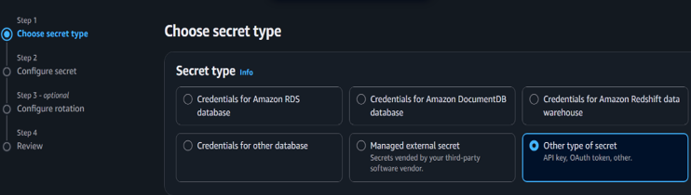
This allows you to create custom key-value pairs.

Step 3 – Create Secret
Under Key/Value pairs, enter:
Key | Value
Username | admin
Password | Example@123
Environment | Production
You can add more keys if required.
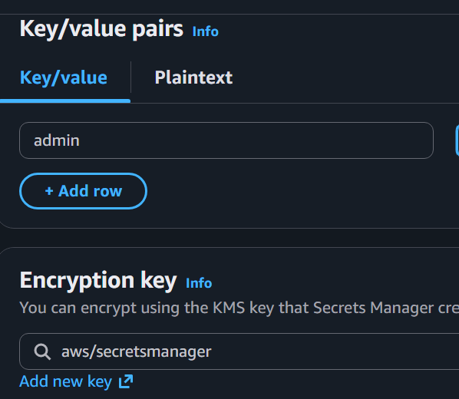
Example:
Key | Value
APIKey | AB12345
Region | us-east-1
Click Next.
Capture the Key-Value Secret Details.

Step 4 – Configure Encryption
Secrets Manager automatically encrypts secrets using AWS KMS.
Keep:
AWS Managed Key
aws/secretsmanager


Step 5 – Name the Secret
Enter:
Secret Name: DevOps-App-Secret
Description: Stores application credentials for DevOps lab.
Click Next.
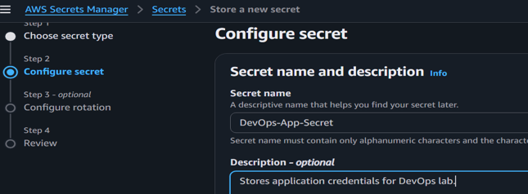

Step 6 – Configure Rotation
For this lab:
Leave Automatic Rotation Disabled.
Click Next.
Note: Automatic rotation generally requires a supported database or a custom rotation function using AWS Lambda.

Step 7 – Review
Review:
- Secret Name
- Encryption
- Secret Values
- Rotation Settings
Click Store.
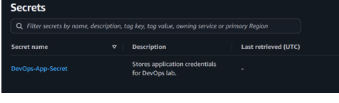

Step 8 – Verify Secret
Open the newly created secret.
Verify that it appears in the list.
Status:
Available
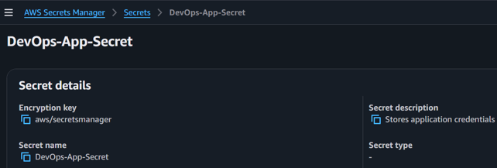

Step 9 – Retrieve the Secret
Open the secret.
Click Retrieve secret value.
You should see:
Username : admin
Password : Example@123
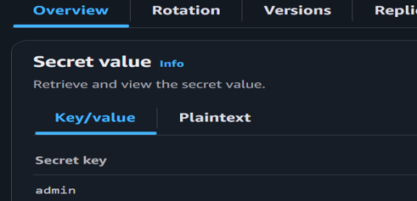
Click close to Hide secret value after verification.

Step 10 – Edit the Secret
Click Edit.
Change:
Password
From
Example@123
To
Example@0549
Click Save.
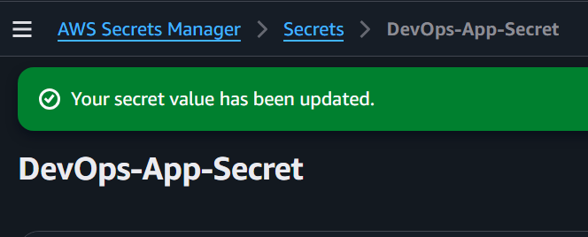
Capture the Updated Secret.

Step 11 – View Secret Versions
Open the secret.
Select the Versions tab.
You should see:
- Current Version
- Previous Version (if applicable)
This demonstrates versioning after updating a secret.
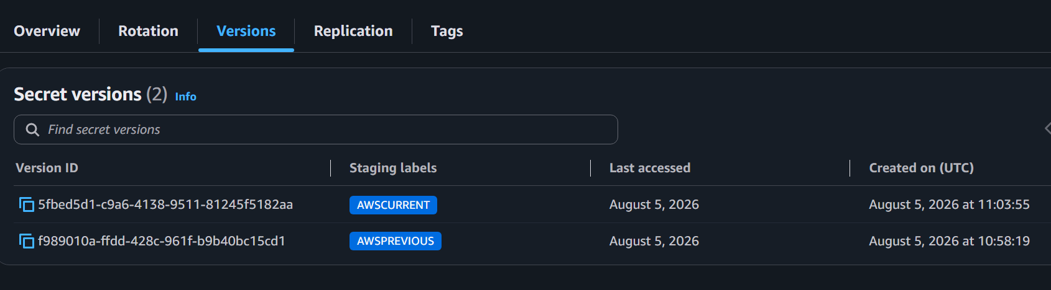

Step 12 – Review Resource Policy (Optional)
Open the Permissions tab.
Review the resource policy.
You may leave the default configuration if you do not need cross-account access.
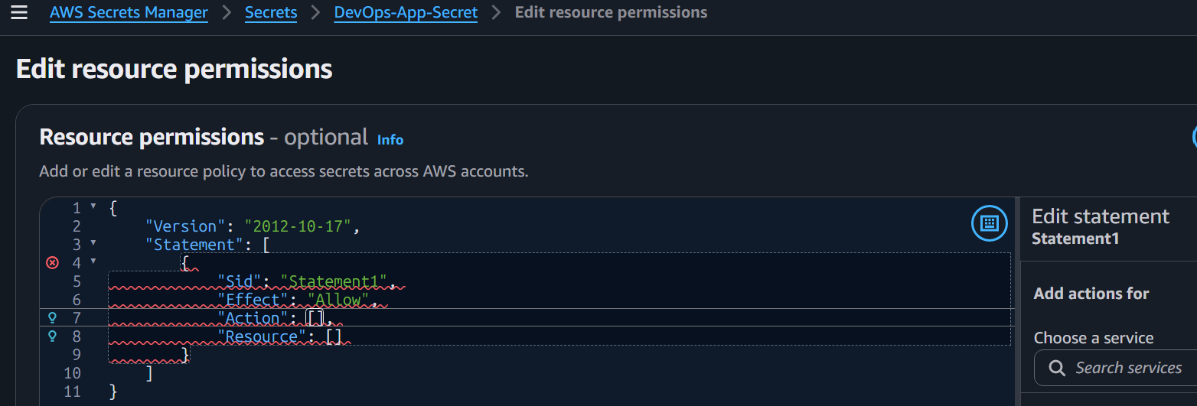

Step 13 – Review CloudTrail Events (Optional)
Open CloudTrail.
Go to Event history.
Filter by:
secretsmanager.amazonaws.com
Verify events such as:
- CreateSecret
- PutSecretValue
- UpdateSecret
- GetSecretValue (if recorded through supported operations)
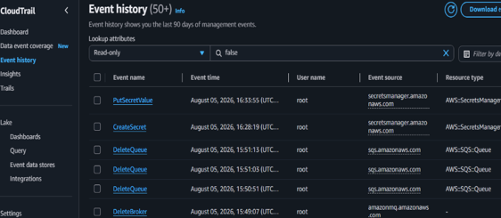

Step 14 – Delete the Secret (Optional Cleanup)
If this lab is complete:
- Select the secret.
- Click Delete.
- Specify the recovery window (for example, 7 days).
- Confirm deletion.
AWS Secrets Manager schedules deletion; the secret is not removed immediately.
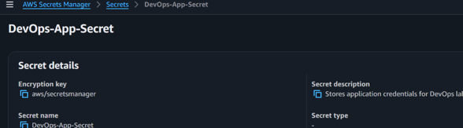
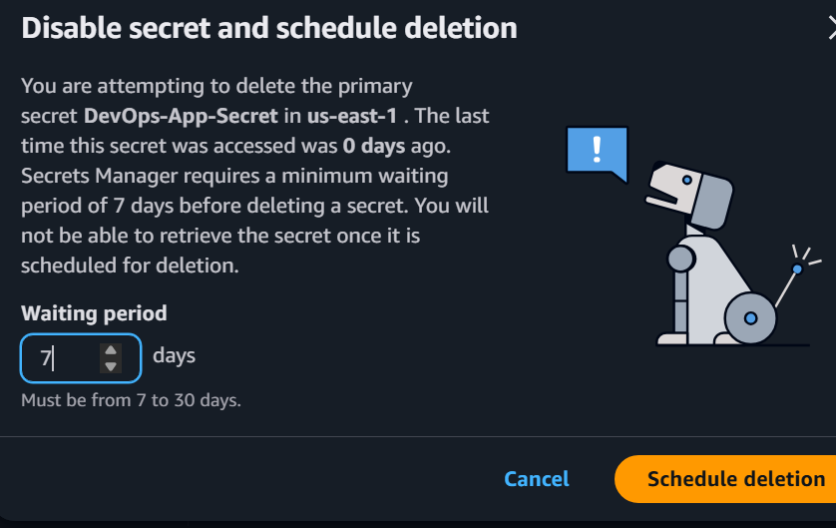

If we want to edit encryption key we can edit the encryption key
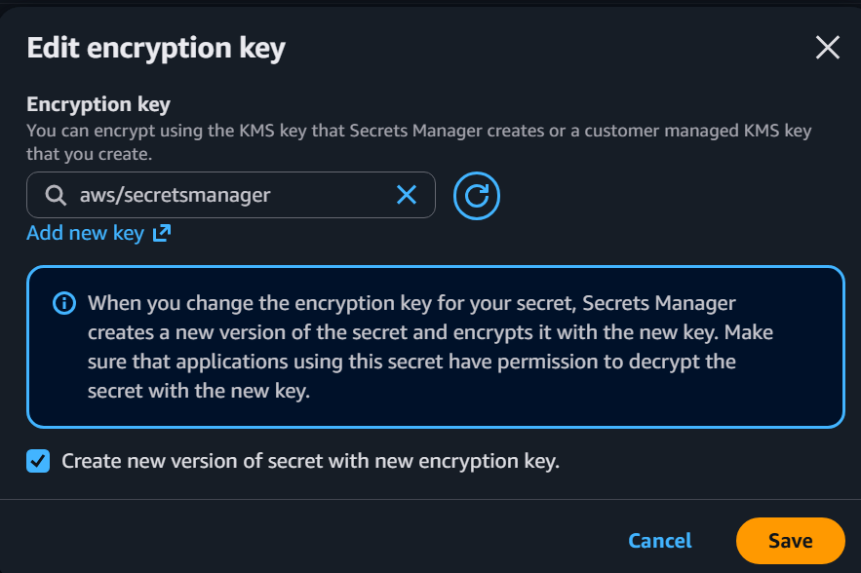

Observations
- Secrets were securely stored using AWS Secrets Manager.
- Secrets were encrypted automatically using AWS KMS.
- Secret values could be retrieved only after appropriate permissions were granted.
- Updating a secret created a new version.
- CloudTrail can record management actions for auditing.
- Secrets can be recovered during the configured deletion recovery window.

